**[Use Case Diagram for Ecommerce Website](https://meeraacademy.com/use-case-diagram-for-online-shopping/)**

Use Case Diagram – Ecommerce Website.

The use case diagram are usually referred to as behavior diagram used to describe the actions of all user in a system.  
All user describe in use case are actors and the functionality as action of system.

Use case for Ecommerce shopping website

[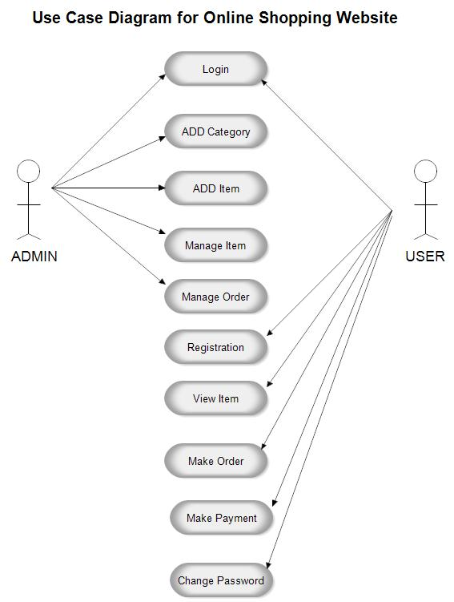](https://www.youtube.com/coderbaba)use case diagram for Ecommerce website